CURRICULUM VITAE

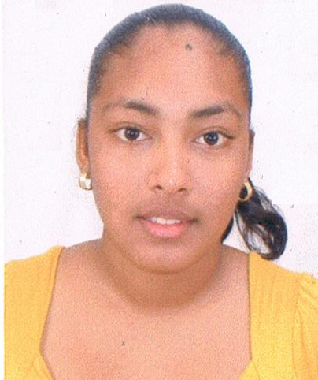

Shirlana Louise Medina

#10 Panchoo Street Ecclesville Rio Claro/Lanse Mitan Road Carenage

1-868-325-2698

Email: shirlana1234@gmail.com

# PERSONAL INFORMATION

**DATE OF BIRTH :** 15th March 1992

**NATIONALITY :** Trinidadian

**SEX :** Female

## MARITAL STATUS : Single

**AGE :** 23yrs

## OBJECTIVE

To provide the Service of an ambitious employee, success in all my endeavors and to be a distinguish asset at your organization and to be a (100%) safe and honest.

## EDUCATION

Ecclesville Early Childhood Centre

Rio Claro A.S.J.A Primary School

Mayaro Composite School

Manzanilla High School

National Energy Skills Centre (NESC)

## QUALIFICATION

* English A
* Human Social Biology
* Mathematics
* Principles of Business
* Social Studies

### COURSES

* National Energy Skills Centre- Computer Literacy

# National Energy Skills Centre- Building Construction Technology

* Y.E.S/ Youth Entrepreneurship Success Programme Lifestyle Management Business Planning
* Guaymay Alliance Computer Studies
* Junior Achievement Business Course

## Certificates

* National Energy Skills Centre- Computer Literacy in May 2004 & May 2008
* National Energy Skills Centre- Building Construction Technology in 2008
  + - Health, Safety and Environment
    - Basic First Aid
    - Steel Bending
    - Blueprint Reading and Measurement
    - Rigging and Scaffolding
    - Basic Concrete Technology
    - Basic Construction Electrical
    - Basic Structural Steel Welding
    - Fabrication and Erection of Steel Structures
    - Layout, Foundation, Excavation and Workshop Calculations
* Y.E.S/ Youth Entrepreneurship Success Programme Lifestyle Management Business Planning in May 2008
* Guaymay Alliance Computer Studies 2005
* Visual Arts- Grade1 in April 2006
* Social Studies-Grade1 in April 2006
* Food & Nutrition-Grade1 in April 2006
* Clothing and Textiles-Grade1 in April 2006
* Music-Grade1 in April 2006
* Digicel 4G Training
* NLCB Certified Lotto Operator

#### Work Experience

Persad D Food King

* Cashier/Inventory Clerk

Click Technologies Computer Service

* As Secretary, Sales Clerk

Intercept Security

* Security Agent

Servisair

* Customer Service Representative

Unicomer Courts

* Cashier/Csr

DIGICEL Cell X Cellular

* Customer Service Representative/Supervisor

Boodrams Lotto Centre

* Lotto Operator/Cashier

Cadel Trading Francis Fashions Shoe Locker

* Cashier/Csr

# Reference

Carlene Persad

Manager

Click Technologies Computer Service

691-2025

Akil John

MANAGER

Cell-X-Cellular

357-4200